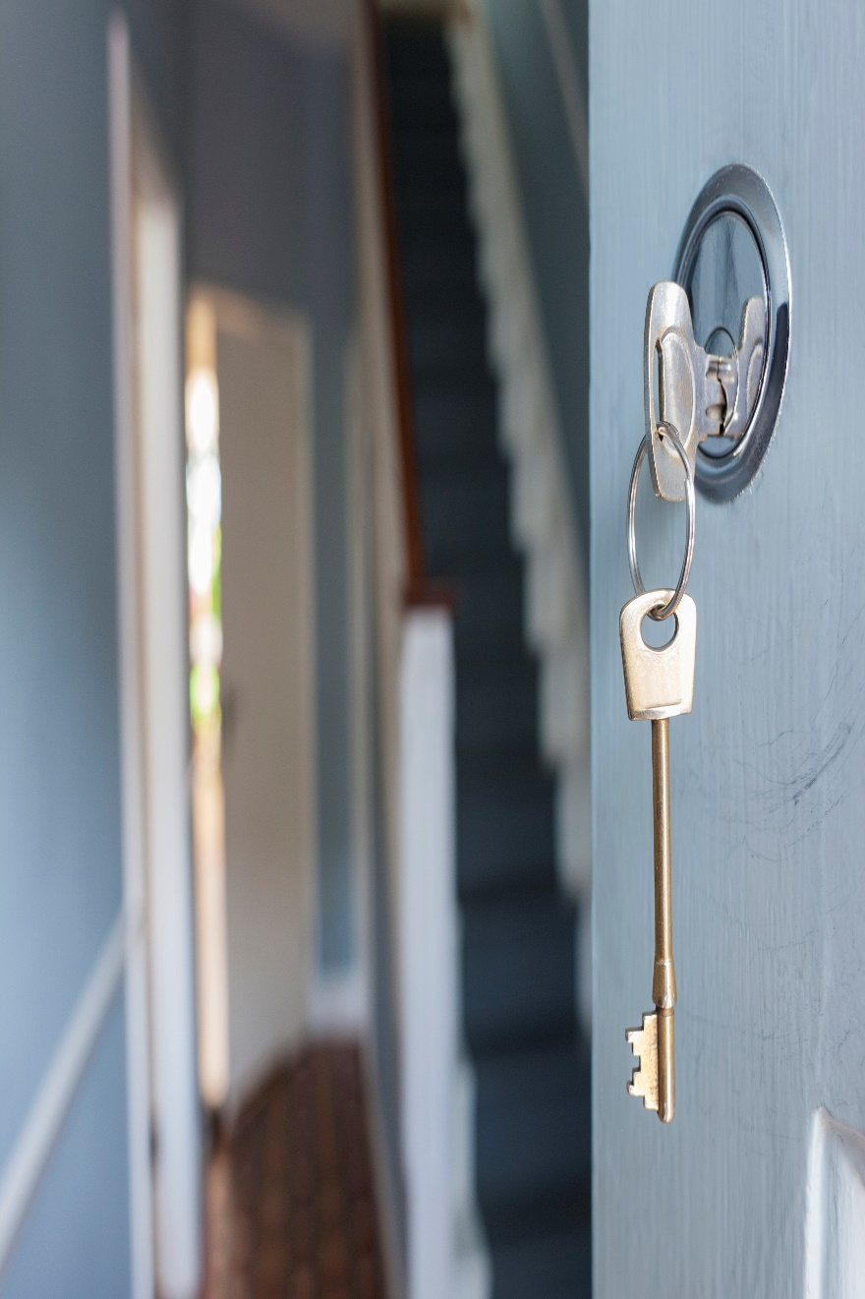

NYC Housing Assistance

owning vs renting

Diego Buonvino, Thomas Fijalkowski | MIS 463 | November 30th 2021

The rent in New York City (NYC) is increasing at a gradual rate, along with the price of the houses. The government is going to have to step in to provide large subsidies to these communities in the form of rent relief. However, Governor Cuomo has advocated for home ownership in these neighborhoods so it can turn into long-term financial well-being and hopefully improve the stability, as well. We must analyze a variety of data so that we can be well equipped to make proper assumptions on what should be done in New York City, particularly the underdeveloped boroughs that may need more help than the rest and were hit the hardest by COVID-19 that lead to mass unemployment. After all the data is cleaned, processed, and examined, we will be able to tell whether home ownership is better than rent, and deep dive into exactly which borough needs government subsidies.

Since the main priority is to analyze the benefits of rent versus home ownership, our first step was to look at the data that contained a lot of useful data on certain real estate statistics. Our first priority was seeing if home ownership is increasing. We can see that it is not based on the graph below.

Homeownership is seen to stay the same from 2005 to 2013 with all the boroughs except for Staten Island having less than 50% of its residents owning property in their borough. Going off this data into the other charts and graphs we will get into, we want to keep in mind that only about 30% of Staten Island’s residents are renting, so a lot of the rent statistics can be ignored when it comes to this borough such as renter income and rent burden.

The housing data found in the NYC data set suggest that cost of having a house is significantly greater than having a condominium. When we look at the graphs below plotted using the NYC dataset, we can see that price of housing is scattered across the plot anywhere from <$100,000 thousand to close to $8,000,000 million but the data suggest that the price for condominium is significantly lower, it only ranges from $35,000 to $160,000 the prices for condominium’s are distributed at much lower price. However we must take into consideration the factor of which borough this home is located in. Manhattan has a very inflated price compared to the other 4 boroughs that have a more affordable price range, depending on the sub-borough.

Both graphs above show the relationship between Price of Houses vs Prices of Condominiums by each NYC borough, when we look at the graph, we see a significant difference between both graphs owning a condominium in NYC is a lot cheaper than owning a single-family house by itself. But the question still remains whether it is cheaper to own or rent a property in NYC?

Since we aren’t given the average rent price of each sub-borough or even of each borough, we had to use renter income and rent burden to analyze whether renting is worth it and if it is as stable as the price of home and condos.

  Looking at the chart above, we see that there is an overall increase of renter income for all the boroughs except the Bronx. These increases are expected because of basic economic inflation, however the fact that Bronx income has stayed the same is concerning. There is no doubt that prices of rent has increased since 2005, so it is already a bad sign that the income in Bronx hasn’t increased like the other boroughs. However, this chart doesn’t tell us much unless we look at the rent burden that can give us a broader look at the status of renting in NYC.

Taking a first glance at this chart we see that Manhattan’s rent burden has stayed fairly consistent throughout the years, which makes sense since this area is fairly wealthy and doesn’t have residents that would benefit from government benefits. We also see that the rent burden in Staten Island has spiked both up and down and is actually at a lower rent burden than in 2005. This is most likely because most people in Staten Island are home owners and more or less well-off. This rent burden represents a minority of renters that live on Staten Island and will not play a factor into the overall analysis of renters in NYC. Ignoring those 2 boroughs, we look at Bronx, Brooklyn, and Queens, all who have had an overall increase in rent burden. Take into consideration that this is not increase in rent price, but an increase in the percentage of overall income going towards rent. Seeing rent burden increase even though renters’ income also increased shows just how costly and exponential the increase of rent is in NYC. Rent seems to be quite unstable in NYC, but let’s take a closer look if the price of renting is truly more than the price of paying a mortgage.

Since we weren’t given the average rent of each sub borough or even the borough, we tried to figure out this statistic by taking the average renter income from 2018 of each borough and multiply it by the average rent burden in 2018 and divide this number by 12 Graphical user interface
months in a year. This was the result:

As you can see, these average rent prices aren’t quite accurate. Rent prices under $2,000 in Brooklyn, Manhattan, and Queens are laughable, therefore we knew that something else needed to be used. So, we used external resources that gave us the average rent prices of Manhattan, Brooklyn, and Queens which are as follows:

Manhattan has an average rent price of $4,208, Brooklyn’s average rent price is $2,951, and Queen’s average rent price is $2,568. Unfortunately, the rent price of Bronx and Staten Island were given, so let’s just use the rent prices from the previous data frame: $1,055 for Bronx and $1192 for Staten Island. Now, let’s compare this to average price of a monthly mortgage in 2018 with the chart below.

This chart was created by taking the average price of single family households for each borough in 2018 and assumed the down payment is 20%. Also, we had to assume that it was a 30 year loan with an interest rate of 4.6%. Looking this bar chart, we can see that the mortgage payments for each borough are higher than that of the monthly rent payment. Therefore, there is an important distinction to point out between renting and home owning. Renting is a better option short term, what does this exactly mean? If you plan on living in the city for a few years you’d definitely be better off renting an apartment where you can most afford it. There is no point of investing in real estate in such an expensive city if you’re going to leave soon, anyways. However, if you plan to live there for a good portion of your life, possibly raise a family, then it would be a good idea to buy a single family house or condominium. There are a lot of benefits that are not explicit, for example the appreciation of your property over time, especially in a fast growing city like New York. The stability of owning a house is also a major plus because you don’t have to worry about the changing economy and what your rent will look like after your lease ends. In order to incentivize owning a house, there are a lot of government funded programs to help home buyers to qualify for a $0 down payment. There are a lot of families in these poorer sub-boroughs that have been in an area for generations that would greatly aid them.

Now that we have determined when it’s better to rent in New York City and when it’s better to own a home, let’s look into the neighborhoods that need the most help and would get the greatest advantage from government subsidies. Creating a heat map and clustering the 5 boroughs will help us analyze this question better.

We created a heat map and clusters on the dependent variables of Price of Condos, Price of Single Family, Homeowner Income, Renter Income, and Rent Burden. Look at the heat map first, we see the Bronx, Brooklyn, and Queens all have a heavy rent burden compared to Manhattan and Staten Island. Also, renter income is very light in Bronx and Brooklyn, proving just how in need Bronx and Brooklyn are for government subsidies. Now, let’s take a look at the clusters. Manhattan is in its own cluster and for a good reason. Manhattan has the lowest rent burden, as well as the highest homeowner income and the highest renter income. This borough definitely does not need government help because of its wealthy population, even though there might be resident living in poverty in the lower east side or north Harlem, they should apply on their own, but the government needs to allocate its subsidies towards a greater population, such as the Bronx. The Bronx is also in its own cluster, but for the opposite reason. This cluster has the lowest renter income, but the highest rent burden. This makes it very hard for resident to live a comfortable life, possibly where they have lived for many generations but have stayed as renters because they do not believe they can be homeowners. Finally, there is the last cluster there contains the three boroughs of Brooklyn, Queens, and Staten Island. What does this exactly mean? There are some neighborhoods in these boroughs that are wealthy that is close to Manhattan level, but at the same time there are sub-boroughs that are in poverty similar to the Bronx. In order to distinguish between these different sub-boroughs we performed a cluster analysis on all the sub-boroughs in these 3 boroughs and it looks like this.

There are 3 clusters there are distinguishable amongst each other by average renter income and average rent burden. Cluster 1 can be seen as having a below average ‘average renter income’, but the highest average rent burden, meaning that most of the people that live in here are paying a large percentage of their salary on the rent living here. Cluster 3 is the other cluster we want to focus on because not only is their rent burden above average, but they also have the lowest average renter income. In the meanwhile, cluster 2 contains the well off sub-boroughs within these 3 boroughs that don’t need the same government subsidies as cluster 1 and 3. So besides all the neighborhoods in the Bronx the other boroughs that are going to get government aid are

**Brooklyn:** Borough Park, Bedford Stuysevant, Bensonhurst, Brownsville/ Ocean Hill, Bushwick, Coney Island, East Flatbush, East New York/ Starrett City, Flatbush, North Crown Heights/ Prospect Heights, Sheepshead Bay/Gravesend, South Crown Heights, Sunset Park

**Queens:** Elmhurst/Corona, Flushing/Whitestone, Jackson Heights, Jamaica, Ozone Park/ Woodhaven, Rockaways

**Staten Island:** Mid-Island, North Shore

Now, it was mentioned previously that Staten Island should be ignored when it comes to rent statistics, this meant in terms of answering the first question whether it’s better to rent or own in NYC. It would be irresponsible to ignore these neighborhoods when they are affected by COVID-19 and these renters are in need of extra help to either pay rent or purchasing a house.

So, now that we know which areas to help in NYC, what kind of help will we give them exactly? First, we want to encourage home ownership, so a good way to incentivize this is by making $0 down payment programs available to many of these residents as mentioned before. If these residents are not interested in home owning then the government will provide rent relief. Now, let’s look at how COVID-19 has impacted these low income areas.

Unfortunately, the NYC housing data given to us only contains data up to the year 2018 when the pandemic began in 2020. We could have assumed and came up with theories, but none of these could have been backed with data. So, we went to external sources to find statistics on the rate of rent and prices of real estate after Covid-19 hit the Big Apple. In an article by the New York Times they state, “And while discounts citywide have been meaningful, they have rarely benefited the tenants most in need of relief. In a StreetEasy analysis of neighborhoods with the lowest rates of Covid infection, affluent areas like SoHo and the Upper East Side in Manhattan saw rents drop 6.7 percent from February to November. But in the neighborhoods hardest hit by the pandemic – predominantly Black, Hispanic and immigrant communities, including Corona in Queens and Kingsbridge in the Bronx – rents fell only 1 percent in the same period” (New York Times). Many people might have the perception that New York was “on sale” during the pandemic and that all of its residents and people that wanted to move their benefitted greatly from it. However, as written by New York Times, this only affected the affluent areas of New York such as Manhattan. These poorer communities still struggled and still need help, especially after the pandemic, so government subsidies is a serious initiative that should be taken into significant consideration.

In conclusion, from this data and other external sources, we found out that prices of houses and condominiums in New York City except Manhattan aren’t increasing exponentially like the prices of rent based on the rent burden. It is clear that owning a house is a better than renting in the city only if you plan on staying long-term as it does not give you much flexibility to move around. The areas that need government subsidies are all of Bronx and some sub-boroughs of Brooklyn, Queens, and Staten Island. Manhattan’s renter income and rent burden look fine and seem to be in a much smaller need for government subsidies. Hopefully the government sees based off this data the struggles the people in these neighborhoods are going through and how hard it is to live in these places with rising inflation and prices constantly increasing. Some of these people have lived here for generations, just because wealthier individuals are moving into the Big Apple doesn’t mean that they should move out.

Works Cited

Parker Waichman LLP. (n.d.). *The New York City rent and housing prices by borough*. Your Lawyer. Retrieved November 30, 2021, from <https://www.yourlawyer.com/library/nyc-housing-prices-by-borough-and-neighborhood/>. ​

The New York Times. (2020, December 29). *The real estate collapse of 2020*. The New York Times. Retrieved November 30, 2021, from <https://www.nytimes.com/2020/12/25/realestate/nyc-real-estate-market.html>. ​